BIRZEIT UNIVERSITY

Faculty of Engineering and Technology

Electrical and Computer Engineering Department

Digital Systems ENCS2340

Verilog HDL Project Report

Name : Mohammad Sheikh

ID : 1221541

DR : Ali Abda

Section : 3

25 / 01 / 2024

# **What are Digital Systems :**

**Digital systems** are designed to store, process, and communicate information in digital form. They are found in a wide range of applications, including process control, communication systems, digital instruments, and consumer products. The digital computer, more commonly called the computer, is an example of a typical digital system. A computer manipulates information in digital, or more precisely, binary form. A binary number has only two discrete values — zero or one. Each of these discrete values is represented by the OFF and ON status of an electronic switch called a transistor. All computers, therefore, only understand binary numbers.

# **What is an arithmetic- logic-unit (ALU)**

An arithmetic-logic unit is the part of a central processing unit that carries out arithmetic and logic operations on the operands in computer instruction words.

In some processors, the ALU is divided into two units: an arithmetic unit (AU) and a logic unit (LU). Some processors contain more than one AU (e.g. one for fixed-point operations and another for floating-point operations).

# **Talking about the given ALU in this project**

As illustrated, In this project, we want in model ALU to recall all the models that you created previously. This means that we must perform all the operations that we added in model ALU (addition, subtraction, comparison operations,...) and we must also draw these operations. The circuit with the view of the Input and Output .

# **Full Adder**

The full adder is a combinational circuit used for evaluating the sum of 3 input,

and can be coupled to create n-bit adders and subtract It is constructed by the use of XOR , AND , OR .

Verilog code:

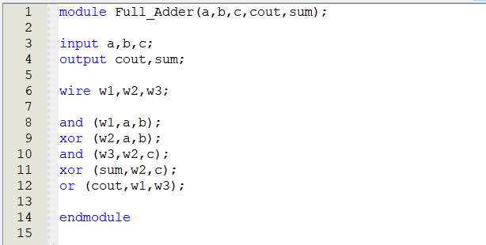

Simulation report :

# **Addition**

We use this to collect 3 bit (input) and it takes out 2 outputs which are Result and Cout (carry) .

And we but the Forcing Low (0) in this Wave , because it’s Add .

Verilog Code :

Simulation report :

# **Subtraction**

We use this module to sub 3 bit (input) and it takes out 2 outputs which are Result and Cout (carry) .

And we but the Forcing High (1) in this Wave , because it’s sub .

Verilog Code :

Simulation report :

# **The ALU**

The ALU (Arithmetic logic unit) is the combinational circuit responsible for

all the arithmetic operations in a digital computer, containing the Full adder,

subtractor, and Addition. The verilog code of which contains all the modules written before, in addition to wires acting as interconnections between

the blackboxes (modules).

Verilog code ( in Data Flow ALU):

Simulation report :

Verilog code ( in Behaviour ALU):

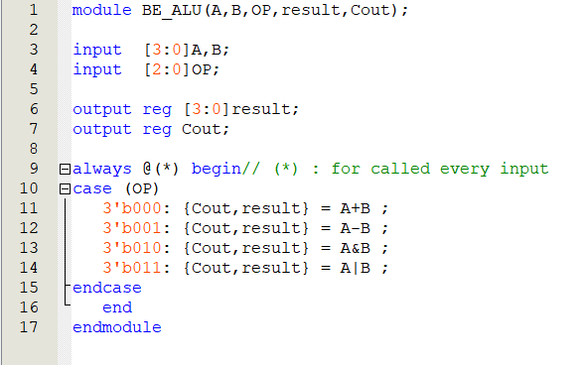

Simulation report :

The Block for Behaviour ALU : Block for Data Flow ALU :

# **ORGate**

We used this model with 2 (Input) and 1(output) to make it easier for us and also according to the project .

Verilog code :

Simulation report :

# **ANDGate**

We used this model with 2 (Input) and 1(output) to make it easier for us and also according to the project .

Verilog code :

Simulation report :